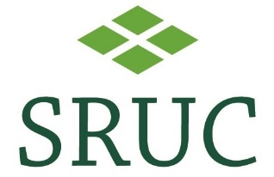
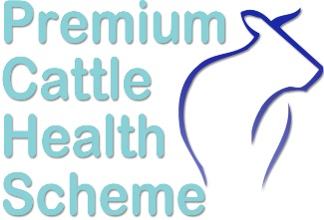
PREMIUM CATTLE HEALTH SCHEME NEOSPORA RISK LEVEL FORM
This form MUST be signed by yourself and your vet if you require certificates for Neospora disease

Member Number:
Herds that do not require a risk level do not need to complete this paperwork.
Mandatory Elements for Accredited Herds : THESE MUST BE IN PLACE
- All female animals of 2 years and over and any females between 12 and 24 months intended for breeding must be tested annually.
- Animals that test Positive for Neospora must not be retained.
- Added animals must be tested as per the CHeCS rules.
- Abortions and clinical cases must be investigated. The minimum requirement is that the aborting dam is tested for antibodies to Neospora.

Advisory Elements
- Placentae, stillborn calves and carcasses must be removed as quickly as possible to a secure location where dogs cannot access them.
- Feed storage facilities must be dog and vermin proof.
- Ensure that feed supplies have not been contaminated by dog faecal material.
- Dogs must be restricted from accessing pasture for cattle grazing and for production of cattle forage.
- Additional Notes

OWNER/MANAGER – I confirm that the Mandatory Elements are being adhered to.
Signed ……………………………………………………………………………..…………. Owner/Manager
Name (block letters) ………………………………….………………………… Date …………….……….

Holding Number (CPH) ……………………………………. Post Code ………………………………

All work is undertaken in accordance with SRUC Vet Services’ Sample Policy, Terms and Conditions and GDPR found on our website at www.sruc.ac.uk/vets
SRUC Innovation Limited. A subsidiary company of SRUC. Registered in Scotland, Company Number SC148684
VETERINARY SURGEON – I confirm that the Health Plan for this herd addresses all the items above.
Signed ……………………………………………………………………………..…………………. MRCVS
Name (block letters) ………………………………….………………………… Date …………….……….

Holding Number (CPH) ……………………………………. Post Code ………………………………

