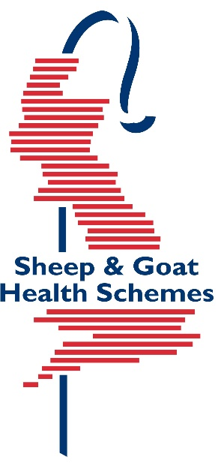
PREMIUM SHEEP AND GOAT HEALTH SCHEME

MV/CAE RETEST Submission Form
Please return samples to:
SRUC Health Schemes, Greycrook, St Boswells, TD6 0EQ

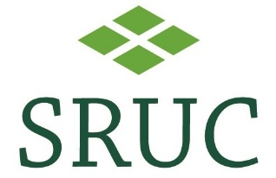

Original Test Ref: _______________

Date of test: ________________________

Veterinary Practice Name and Address | Client Name and Address
Clinician: | CPH Number:

Please note if you require any non Health Scheme tests we require a separate blood sample and a completed farm animal submission form

Test Type | No. of animals tested
Retest of Positive Animal(s) from the Routine Periodic Blood Test

Retest of Positive Animal(s) from the 12 Thin Ewe Screen

Retest of Other test: Please specify

Declaration by Owner and Veterinary Surgeon
(This form is invalid if this section is not signed by the owner and veterinary surgeon)
I agree to abide by the rules and conditions of membership. All information provided is correct at the time of recording.

Signed:…………………………………………………………………… Owner/Manager

Name:……………………………………………………………. Date:………………

I have explained the rules of the scheme to my client who, to the best of my knowledge, is complying with the rules and conditions of PSGHS.

I have blood sampled, according to the rules, the appropriate number of animals.

VET - Signed:…………………………………………………………… MRCVS

Name:……………………………………………………………… Date:………………

Please submit bloods in their boxes in the same order as listed below or an admin charge will be imposed if we have to re-order the bloods. |  |  |  |  |  | TEST(S) REQUIRED
For office use | Tube No | Ear No | Age | Breed | Sex | MV/CAE
1
2
3
4
5
6
7
8
9
10

